CHAPTER ONE

INTRODUCTION

1.1. BACKGROUND OF RESEARCH
Energy systems facilitating power generation serves as the basic source of power for home appliances and industrial equipment’s use. There are several available Energy sources harnessed for power generation which could be succinctly classified into Non-renewable and renewable sources. These diverse sources enables various technique for power generation which engenders a variety of power generating systems. However, the low efficiency, unreliability and poor environmental friendliness of some generating systems poses more challenges than it solves hence, this brings about the idea of combining two or more alternative local energy generating systems which serves in complementing energy when the primary supply falls short of the required demand or when certain energy sources becomes unavailable. This also necessitates the movement towards a green technology which can alleviate the threats to climate change and improve the efficiency of such power systems.
Nevertheless, the performance of the generating facilities harnessing energy sources would not be fully optimized provided a significant part of the energy consumed is due to improper use of appliances and devices, leading to energy wastage. Residential and business buildings account for the major percentage of world-wide energy consumption, with an increasing trend over time. The main causes of energy consumption in buildings are space heating and conditioning, water heating, lighting, and the use of computers and other electronic devices. However, The major sources of energy wastage is exemplified by having electrical appliances in standby mode for long hours, having light bulbs left ON all through the day, underutilizing power generation facilities etc. Recent experimental study has shown that more than 30% of the generated energy is being wasted as a result of various forms of energy mismanagement {Sheetal Shinkhede., 2015).
While power systems and information technologies are converging to revolutionize the way electricity is generated, delivered, managed and consumed; new challenges arise such as: how to integrate storage efficiently, how to use demand-response of household appliances usage to mitigate peak demand, how to Minimize or keep the energy consumption of the whole household as constant as possible, how to minimize global fluctuations in energy consumption etc. this can be surmised as: how should resources be allocated in home energy management systems (HEMS) as the stochastic nature of their availability (generation, storage, and loads) becomes prevalent? As against the transmission level, where relatively few numbers of assets, although rated large, are used; the smart Home Energy management System (HEMS) is expected to transform distribution, where a multitude of smaller assets will be available for controlled deployment.
This research seeks to investigate the trend of stochastic supply of the National Grid within the immediate environment of the University of Ibadan, the available and affordable alternative renewable energy resources and propose a rule based smart home energy management approach that can harness the various energy facilities, and schedule electricity demand/supply by considering: the state of the smart grid, local power generation capacity, Renewable energy availability, energy storage units capacity and time-based electrical consumption of household appliances.
The prediction of weather conditions and the immediate and longer term plans of the residential home occupants are crucial parameters in the proposed smart home decision-making system that acts on behalf of the occupants. This research aims to provide a motivation example/associated scenarios, electrical energy supply/demand models and scheduling schemes for a smart home electricity management system in the context of a smart grid, smart appliances, and local renewable energy resources.

1.2. PROBLEM STATEMENT
The increased reliance on the deficient National power supply grid by the exponentially increasing building structures provokes further imbalance in the demand/supply structure as the present capacity of the national grid is without gain say insufficient to cater for the ever increasing demand for power. Hence, the movement to compensate household energy supply with energy sources such as PV, Fossil Fuel reliant Generators, wind turbines etc. since the frequent, unexpected truncation of power supply engenders information loss, business interruption etc. However, with alternative local renewable energy facilities, power loss can be manually compensated while threats to climate change is reduced.
If there exists two or more renewable energy alternatives, a connection and reconnection problem arises in cases where energy sources are simultaneously used up and the next available source is connected. Hence a laborious routine of imperfect manual power scheduling; since the alternative energy sources might have different power ratings. This necessitates the need for a smart rule based Home Energy Management system.

1.3. AIM OF THE PROJECT
This project aims to adopt a Heuristic approach for smart home energy management as a comprehensive solution, which takes account of the local renewable energy generation, smart grids, smart electronic appliances, and environmental factors. The approach aims to proffer a rule based solution to enhance energy management and minimize the overall daily electricity cost of household appliances, taking into account Renewable energy Availability, predictable home activities, and the flexibility of electricity use.

1.4. OBJECTIVES OF THE PROJECT
The primary objectives of this project are:
- To device a Rule Based load management approach which aims to:
- Take into consideration, the stochastic variation in the National Grid/renewable energy supply
- Use demand-response of household appliances usage to mitigate peak demand
- Minimize/keep the energy consumption of the whole household as constant as possible and integrate storage efficiently.
- To propose how resources should be allocated in home energy management systems (HEMS) as the stochastic nature of the availability of resources becomes prevalent.

1.5. METHODOLOGY
In order to achieve the above stated objectives, the following approach was taken:
- A typical home setting was adopted within the immediate environment of the University of Ibadan, and the stochastic variation in the availability of the accessible Renewable energy sources was evaluated.
- The total load obtainable due to the use of various appliances in practical scenarios was formulated and with respect to time, the load usage was sorted into Peak and off peak load periods
- With regards to the available renewable power, Schedulable Appliances was defined and rules written to define their scheduled usage.
- Automatic shifting of energy consumption from grid draw to renewable power in case of power outage (grid resilience) was objectified by set of rules.
- The Energy management requirement analysis was conducted and set of rules which achieves the load/energy management by shifting/scheduling of loads and energy storage was written
- The flow chat of the program was designed taking cognizant of the requirement analysis and system design
- The proposed C++ rule base Algorithm was to implement the complex decision, and load scheduling with respect to the defined rules was written
- Unit and integration testing on the rule based HEMS program was thereafter conducted to ensure compliance with the predefined rules
1.6 JUSTIFICATION FOR PROJECT
It was observed that most home running renewable energy facilities alongside the national grid supply lacks an efficient power management and monitoring scheme that ensures the optimum use of these renewable energy facilities and an optimized power scheduling structure. This lack contributes to power mismanagement, cost-ineffectiveness and eventually power wastage or Overloading of the system.
Also, several papers written mainly focused on cost reduction by load management and power scheduling in environments with dynamic electricity tariff i.e. having varying cost at peak and off-peak periods. Hence, their cost optimization pattern is not applicable in third world countries like Nigeria where the power usage has a fixed tariff per kilowatt.

CHAPTER TWO
2.1 LITERATURE REVIEW
An attempt to mitigate the effects of climate change due to the burning of fossil fuel and to meet the increasing energy demand has informed multi-dimensional researches into the use of renewable energy source for power generation. Thus, exploration of renewable energy sources such as hydro, solar, wind, and geothermal energies, has gained global attention
There is an emerging trend for residential homes on smart grids to have local electric power generation as a portion of electricity supply. Alternative power generation usually comes from photovoltaic systems, wind turbines, fossil fuel reliant Generators etc. With the incorporation of distributed renewable energy generators, the present power system is transformed into a large-scale distributed generation system (Koutsopoulos and L. Tassiulas., 2011; B. Ramachandran et al., 2011). In the classical centralized power network, electric power flows from power plants to the customer premises in a one-way supply mode. Distributed renewable energy resources bring new situations of local electricity production and two-way electricity flows which dramatically increases the control requirements on the grid for efficient load monitoring, power scheduling and management.
According to a number of studies, providing appropriate feedbacks to building occupants can significantly reduce the overall energy consumption, in the order of 5-20% (M. Chetty et al., 2008);. However, only relying on people’s awareness and behavior may not be an effective approach. Indeed, a recent experimental study (X. Jiang et al., 2009) has shown that more than 30% energy saving was achieved immediately after installing a monitoring system in a residential household, but the percentage reduced to less than 4% one month later. A rule based automated energy management system in addition to user cooperation would be certainly a more effective solution.
The Renewable Energy Sources (RES) such as wind and solar have the challenge of intermittency and unpredictability as a result of their dependency on weather and climate conditions(Ayodele TR, Ogunjuyigbe ASO., 2016; Ayodele T.R, Ogunjuyigbe A.S.O., 2015). Therefore, a stand-alone PV or wind system will only be able to meet the load demand only for the time periods when the solar radiation or adequate wind speed are available. Consequently, when using renewable energy source(s), a backup energy source and or storage system is usually needed. The backup energy source supplies energy at such times when the renewable energy (solar radiation/cut-in speed) is unavailable. On the other hand, power supply from Diesel generators is predictable and independent of climate. However, the use of Diesel generators have drawbacks such as environmental pollution by carbon (iv) oxide emission (Yang H et. al., 2008) and high costs of operation and maintenance.
In view of the shortcomings presented by both the renewable and non-renewable energy sources, different alternative energy sources are made to complement one another to some extent. As
such, properly sized and designed multi-source hybrid alternative energy systems (with proper control) have greater potential to provide higher quality and better reliability compared to a system based on a single source of energy. Several alternative energy sources including wind, Solar PV, biomass, tidal, Fuel cell, diesel system, gas turbine, mini and micro turbines as depicted in Fig. 1 could be utilized in the design of hybrid energy system depending
on the availability of their primary energy resources. Of these various sources, wind and PV systems are the most popular for hybrid energy design due to their availability in almost every region of the world. However, the intermittent nature of these resources require energy storage devices and or some other generation sources to form part of the hybrid energy design (Hutardo E et al 2015; Ayodele TR, Ogunjuyigbe ASO., 2015).

Also, most of the hybrid energy designs in the aforementioned studies are based on the combination of available resources that give the least cost of energy. Hence the underline objective function is cost. However, to utilize hybrid energy sources effectively, economically and in a more environmental friendly manner, there are additional objectives that are needed to be taken into account. These objectives are achieved using various optimization techniques. Some of the objectives to be considered in the design of hybrid energy systems to includes costs minimization, energy wastage minimization and CO2 emission reduction (Yang H et al. 2008). Different optimization techniques have been utilized in achieving these set objectives (Hutardo E. et. al., 2015), (Kaabeche A. et al., 2015), (Ziyon S. et al., 2015). These include dynamic programming, probabilistic approach, linear programming and iterative techniques.
Smart grids employ modern information and communication technology to achieve computer-based remote control and automation of utility electrical networks. There has been extensive research, development, and deployment of smart grids (H. Farhangi, 2010; J. A. Momoh 2009) across the world in recent years. Smart grids assist in more efficient use of existing power system assets through demand response, peak shaving, and service quality control. Smart grid technology changes the power system into a complex adaptive system (S. Massoud Amin and B. F. Wollenberg., 2005).
Major suppliers of smart appliances include Samsung, LG, GE, and Whirlpool. Smart appliances normally have the capability to react to electricity price and demand response signals. They bring additional value with intelligent control, power management, and networking technologies for
Household appliances on the Smart Grid (T. Catania., 2012; J. Stragier., 2010).
Distributed generation by local renewable energy sources has gained worldwide attention (P. C. Loh, L. Zhang and F. Gao., 2013; J. M. Carrasco et al. 2006) and has employed energy informatics which is concerned with analyzing, designing, and implementing systems to increase the efficiency of energy demand and supply systems (R. T. Watson et al. 2010).
Smart home systems are widely referred to as “home automation”, which has attracted more attention in recent years due to the development of control systems for entertainment, heating, broadband, lighting and security from one of many types of digital computer control devices, panels and mobile handsets (P. Pellegrino et al. 2006). An overview has been presented in (D. Markovic et al., 2012) of the challenges of smart homes that information and communication technology will face in the residential home environment. The relationship between human and automated intelligence in green buildings is explored in (R. J. Cole and Z. Brown., 2009).
A simulation system for validating contextual rules in smart homes is proposed in (P. Joonseok et al., 2007). An agent-based smart home, referred to as MavHome, is proposed in (D. J. Cook et al., 2003) in which a home acts as an intelligent agent in an adaptive and automated environment. A rule-based framework is proposed in (C. Leong, A.R. Ramli, and T. Perumal., 2009) based on an Event-Condition-Action pattern inherited from the field of expert systems for heterogeneous subsystems management in smart home environment.
Smart home systems focusing on energy efficiency have been discussed in multiple articles. Most of this literature focuses on cost reduction by load management through dynamic electricity tariffs in smart grids. As an extension of this previous work, this Research proposes a new approach for smart home energy management as a comprehensive solution, which takes account of the local renewable energy generation, smart grids, smart electronic appliances, and environmental factors. The approach aims to minimize the overall daily electricity cost of household appliances. The minimization needs to take into account predictable home activities, and the flexibility of electricity use. Scenarios,
2.2 HISTORICAL DEVELOPMENT OF SMART HOMES & BUILDINGS
The concept of smart homes/buildings has existed for many years, which comes from home/building automation, enabling people control the lights, gate, HVAC and other households through intelligent controller go-as-you-please (F. K. Aldrich, 2003). However, due to the limitation of electric, electronic, communication, computer and control techniques, the smart homes & buildings were difficult to be established before early 20th Century (R. Harper, 2003). Along with the widespread of electrical appliance such as TV, HVAC, wash machine, and cloth dryer during 1920s-1960s, the establishment of smart homes/buildings began to have a solid physical basis (R. S. Cowan, 1976). Correspondingly, X10, the first communication protocol for home appliances through power line, was established in 1975, aiming to help people easily control their household devices (D. Cook and S. Das, 2004). With the assistance of X10, the home appliances can be monitored and controlled using the 22-bit long data package transmitted on the power line. Since 1980, the realization of operating home appliances through the assorted interface on the personal computer is regarded as the rudiment of Smart Home. After 1990s, with the springing up of ICT, the telecommunication technique, wireless communication technique and Internet technique were able to integrate into the smart home/building systems in succession. A number of wire/wireless communication protocols for household devices such IEEE 802.11 Wireless LAN, 10 Bluetooth and Home RF were invented during the last ten years in 20th century (X. Feng, 1999). However, the prices of computer, microcontroller and communication components were too high to be used in smart home system during the last decade, which restricts the introduction of smart home system into normal people’s life. Started form the 21st Century, because of the rapid development of ICT and reduction in price of related electronic components, the smart home and smart home related products, such as wireless power socket, automatic lighting systems and thermal controllers, became affordable for ordinary customers (V. Ricquebourg et al., 2006). In addition, the USA president Obama put forward the concept of smart grid in 2008, and aims at building a smart self-monitoring, cost-effective and environment-friendly power grid with the assistance of modern IT and renewable energy techniques, which makes smart grid become greatly attractive for both industry and academic (P. Fox-Penner et al., 2010). In addition, as the integral factor of the smart grid, smart home has also received more attention than before. As an inviting market, a large number of leading companies, such as Google, Microsoft, Cisco, Apple and GE, have started to develop and launch their smart home products in order to occupy the smart home & building market.
2.3 THE HOME ENERGY MANAGEMENT CONCEPT
Home automation is a matured technology. The use of thermostats in the early 1900s to maintain heat levels was a major step in ensuring efficient use of energy. The system has grown over the years into other fields such as security systems, entertainment, energy-efficient appliances, HV AC control, ehealth and remote controls. The concept of smart grids with its inherent ICT makes energy management in the power sector more effective and efficient. Though growth in ICT systems far exceeds energy consumptions in other areas, it can reduce the energy consumption of other sectors by introducing intelligent monitoring and management systems. Smart HEMS, as a mini smart grid, can contribute to reduction in energy consumption of household appliances using intelligent monitoring and control systems. The home environment is an excellent reduced model of a public grid. It could be termed a "home microgrid" as it can comprise generation, distribution, and load all encapsulated in this environment. The implementation of low-power wireless sensors networks enhances this smart grid concept in homes enabling EMS capabilities. Smart HEMS therefore balances energy efficiency and savings with comfort levels of the inhabitants. In summary smart home energy management offers either of the following functionalities:
- Informative: Where overviews of information about energy usage data in various graphical forms (bar graphs, pie charts, etc) to the users.
- Automated: This offers customer options to set priorities and wishes for the operation of household appliances and/or local generations.
- Advanced: This includes information, automation and control either locally or from third parties. Also includes the possibility for forecasting and scheduling of loads.
- Residential loads: This is divided into two: grouped loads and individual controllable and uncontrollable loads. These loads are either modelled from either measured data from residential customers or simulated with Simulink simpowersystems. However, in this thesis measured data was used.
- Local generation: In some households, photovoltaic system, solar collectors or micro-CHPs are present for onsite generation.
- Home automation: This consists of alarms and sensors.

2.4 ENERGY MANAGEMENT SYSTEM (EMS):
This is the heart of intelligence and control. All the measured, sensed, downloaded and exchanged data are processed in this block. The EMS also manages the energy consumption by balancing generation with demand or minimizing cost as the case may be. It engenders involves effective and efficient use of energy (either generated locally or from the utility grid). For residential customers, it is reflected in the reduction of their energy bills or a good balance between local generation and consumption.
In general homeowners with on-site generation are more inclined to incorporate SHEMS as opposed to the normal household residents. In this section, optimization schemes are investigated for a grid-connected household with on-site generation. Energy flows bi-directionally (to and from the utility grid) and there is no local storage. Two parameters are chosen for the integrated optimization: cost and local demand-supply optimizations.

2.5 HOME ENERGY MANAGEMENT SYSTEMS (HEMS)
HEMS, refers to a hardware and/or software system that can: Monitor and provide feedback about a home's energy usage, and/or also enable advanced control of energy-using systems and devices in the home. HEMS utilize renewable energy effectively by visualizing load equipment information in the home (such as water heater, storage battery and EV) and controlling it properly. They contribute to the reasonable peak shifting and load shifting according to the information of supply and demand arrangement request from community energy management system (CEMS) and also Calculate necessary power quantity from demand forecast and output forecast of photovoltaic, and store in storage battery and EV in advance to contribute to maintain minimum energy life in an emergency.
2.5.1 HEM OBJECTIVES AND BENEFITS
Home Energy Management technologies serve the primary purpose of enabling residential users to manage home energy use by reducing consumption (D.M Han et al., 2011, W. Wang et al., 2013) or shifting/trimming peak demand. This enables households to “select and implement a strategy for their use of energy” (Delphi participant) and delivers benefits such as a better understanding of their energy use, better information about energy use in the home, and insight into problems with equipment (i.e. fault detection). The benefits of HEMS to the user go can go beyond the modification of energy consumption patterns Benefits of HEMS from the consumer perspective include “to save money, live more comfortably, and save time” and “comfort, convenience, and control. The importance of these non-energy benefits is starting to be reflected in products emerging on the market; as the makers of Nest say, “It’s about making your house a more thoughtful and conscious home. HEMS have the opportunity to play an important role in bringing together the objectives of households and utilities around energy management, meeting policy objectives around greenhouse gas emissions reductions, and securing a reliable energy supply. HEMS are most often characterized by their ability to provide the user with
- feedback about energy use in the home,
- information to help users manage their energy consumption,
- Control of household appliances and devices.
Many descriptions highlight their ability to provide not the user, but a third party (e.g., energy utility Defining HEMS Based on these characterizations, generates an operational definition of home energy management technologies as those that enable households to more actively manage their energy consumption by providing information about how they use energy in the home or to prompt them to modify their consumption, and/or providing the household (or third parties) the ability to control energy-consuming processes in the home.
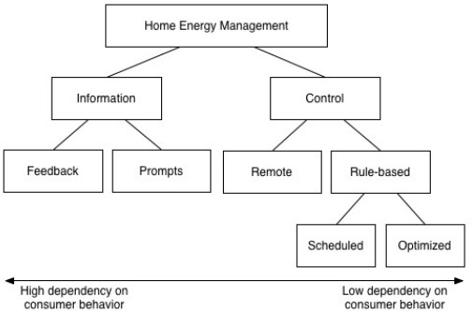
Figure 2.1. Home Energy Manage Functionalities
2.5.1.1 INFORMATION
The information function of HEMS refers to the ability of systems to provide feedback on energy usage back to the energy user. This functionality is further broken down to feedback and prompts.

2.5.1.1.1 FEEDBACK
Feedback refers to the process of giving people information about their behavior that can be used to reinforce behavior and/or suggest behavior change. In the context of home energy management, feedback specifically refers to information about household energy use and is often referred to as energy feedback or eco-feedback i.e., information about actual energy use that is collected in some way and provided back to the energy consumer. The provision of energy feedback (i.e., information) has been identified as a key defining functionality of HEMS
2.5.1.1.2 PROMPTS
Prompts are another form of information that HEMs provides; they do not provide information on energy usage, but rather send targeted or timed suggestions to the energy user that enable them to more actively manage demand. Often in the form of time of use pricing tariffs, economic incentives, and actionable advice, prompts can help users to shift the time of use of an appliance, increase the efficiency with which actions are performed, or swap one activity for another less energy-consuming one that provides the same service. Prompts provide consumers information and incentives to trigger them to shift their power demand patterns.
2.5.1.2 CONTROL
The purpose of the control module is to provide the control of the necessary parameters. It provides the functionality required to control the load in case of peak period or in case of exceeding the threshold boundary. It offers control functionality, e.g. load shedding, on/off load control, direct load control, power quality control. The control is mostly achieved with the aid of preprogrammed rules which determines the decision taken by the HEMs in practical scenarios. This research aims to adopt a heuristic approach which is a series of if-then statements that utilizes a set of assertions, to which rules are created on how to act upon those assertions.it perfectly controls/provides answers to problems in place of human experts.

2.6 LOAD MANAGEMENT
This Served as a critical part of Demand Side Management (DSM), load management is an indispensable part for reducing peak load and back-up power plant. Hence, governments and EMS manufacturers' have drawn a lot of interests on its investigation and development. For load management, controllable loads such as air conditioning, space heater, water boiler, and other residential appliances have been concerned as the main aspects In order to promote the load management of Demand Side Management (DSM), the energy suppliers in advanced countries provide various tariffs with flexible prices rather than constant prices to customers. In this way, customers can be encouraged to make their energy consumption plans based on the electricity prices. Even though the electric prices of different tariffs vary from country to county, the electricity tariffs can be generally classified into three types – TOU, RTP and CPP (shown in Figure 2-1) according to the pricing mechanisms.
2.6.1 TIME OF USE TARRIF (TOU)
The TOU tariff defines the electricity price according to specific time periods within a day, and each time period corresponds to a fixed price which is decided by the power grid demands level (e.g. Off-peak, mid-peak and peak). This kind of time-based pricing service is aimed at encouraging customers shift their energy consumption from peak time to off-peak through price incentive.
2.6.2 THE REAL TIME PRICING (RTP)
The RTP price changes every one or half hour, is determined by the real price in the energy wholesale market. The customers would obtain the predicted day-ahead RTP price to plan their energy use in advance.
2.6.3 CRITICAL PEAK PRICING (CPP)
The CPP tariff is similar to TOU, but has a critical peak time with a higher price than the peak time price in TOU.
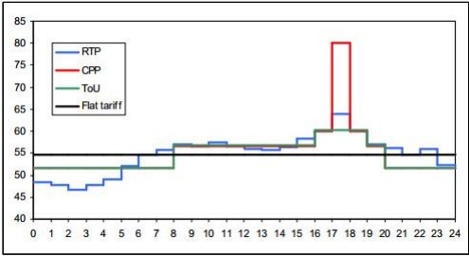
^{Figure 2.2:} Graphical Illustration of Flat, TOU, CPP and RTP Tariff.
According to the pricing principles of TOU, RTP and CPP, customers need to make estimations or measurements of utilities if they want get economic benefit from the flexible tariffs. However, it is difficult to make customers control their loads timely or change their energy consumption habits to response the changing tariffs. Therefore, the load management feature is developed as the important part of EMS to help customers manage their utility automatically and smartly with the assistances of the automatic monitor, plan and control systems. With the wide installation of smart 15 meters and the adoption of Smart Home & Building systems, a solid platform is established for providing various modern electricity tariffs. The load management can be introduced as a service in EMS, which optimizes the load operation plan based on the collected data and request the device execute the plan through the physical area network.
2.7 ARCHITECTURE OF HOME ENERGY MANAGEMENT SYSTEMS
The overall system architecture is composed of two subsystems, namely the monitoring and the control subsystems. The monitoring subsystem at prefixed time intervals measures the energy consumption of the analyzed electrical appliances and some environmental and context information (e.g., temperature, light intensity, presence of persons). The latter exploits the data collected by the monitoring system and some energy conservation strategy to control the behavior of each single appliance.
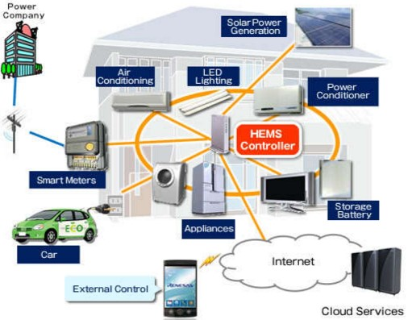
^{Figure 2.3:} ^{HEM System Acchitecture.}
The control subsystem is aimed at controlling the behavior of each single appliance on the basis of information provided by the monitoring subsystem and on energy conservation strategies defined by the user.
    - MONITORING SUBSYSTEM
The monitoring subsystem employs a number of electricity and environmental sensors for, respectively, measuring the power consumption of each single electrical appliance in the building, and monitoring parameters such as temperature, light intensity and human presence. Data collected by both types of sensors are wirelessly communicated to a base station and, then, conveyed to a central server. The communication between base stations and the server typically occurs through a wired LAN. The server processes the data and provides users with real-time and/or periodic reports on energy consumption and costs. It also sends alert messages to notify specific events. The monitoring provides accurate knowledge of the systems characteristics with maximum, minimum and average values for voltage, current, power values, frequency.

2.7.2 CONTROL SUBSYSTEM
The control subsystem manages the behavior of each single electrical appliance, according to energy conservation rules specified by the user, so as to minimize electricity wastes in the building. The subsystem employs one actuator. The purpose of the control module is to provide the control of the necessary parameters. It provides the functionality required to control the load in case of peak period or in case of exceeding the threshold boundary. It offers control functionality, e.g. load shedding, on/off load control, direct load control, power quality control.
For each single controlled electrical appliance and a set of controllers that coordinate the actuators. Controllers are connected to a central server, through a wired LAN technology (i.e., Ethernet). The server generates commands such as “switch on” and “switch off”, for each specific appliance in the building: commands are sent to the corresponding actuator through the appropriate controller. The sensing and actuation functionalities could be integrated in the same device, i.e., the electricity sensor could also act as actuator for the associated appliance. On the other hand, several integrated wireless sensor/actuator platforms are already currently available on the market. Adopting an electricity sensor for each appliance is expensive and often not necessary: A single sensor can be sufficient to monitor a group of devices and take decisions on the behavior of the single device. Obviously, in order to control each device autonomously, we need to have an actuator for each device. If integrated wireless sensor/actuator platforms is adopted, sensors will be adopted for each appliance. As an alternative, two different infrastructures could be used, one for monitoring and the other for control.
2.8 ENERGY CONSERVATION STRATEGIES
The system architecture described above allows a flexible and efficient management of each single appliance and, hence, provides the potentials for implementing appropriate energy conservation strategies for each appliance (or class of appliances). The following are list of possible strategies for home energy conversation.
- User awareness
- Reduction of stand-by consumptions
- Scheduling of flexible tasks
- Adaptive control of electrical appliances
2.8.1 ENERGY AWARENESS:
User awareness about energy consumptions is the primary form of building energy efficiency. According to a number of studies, providing appropriate feedbacks to building occupants can significantly reduce the overall energy consumption, in the order of 5-20% (M. Chetty, D Tran, R. E. Grinter., 2008). To this end, GreenBuilding allows users to get detailed and real-time information on the energy consumption and status (i.e., on/standby/off) of single appliances, even remotely. The system can also send periodic reports (e.g., by e-mail). Finally, GreenBuilding can send alert messages to the user’s portable device when some specific events occur (e.g., a device is active when it is supposed to be inactive), also suggesting possible actions to save energy.
2.8.2 ELIMINATION OF STAND-BY CONSUMPTIONS:
Feedbacks on energy consumptions can make the user aware of possible energy wastes, e.g., standby consumptions. In order to automatically eliminate (or drastically reduce) standby wastes, GreenBuilding allows the user to specify an appropriate management strategy for each specific appliance. The system is able to recognize when an appliance is in standby mode and take appropriate actions to execute the strategy defined by the user. For example, the system can switch off a certain appliance after a predefined time interval has elapsed from when it entered the standby mode.
2.8.3 SCHEDULING OF FLEXIBLE TASKS:
Some energy consuming tasks that do not require a directly user involvement can be scheduled for execution at some pre-programmed time, e.g., during night, when the energy cost is lower. Examples of such tasks include all those associated with white goods (e.g., washing machine and/or dishwasher). GreenBuilding allows the user to specify the exact time or time interval (e.g., the slot time when the energy costs are lower) when a certain task is to be executed by a specific appliance (e.g., the washing machine). Using a standby elimination rule, in addition to appropriate scheduling, can actually minimize the energy consumption of electrical appliances executing flexible tasks. For example, the washing machine can be switched on by the system only at the pre-programmed time. Once the task has been completed the appliance enters the standby mode. This is detected by the system and the washing machine is then switched off.

2.8.4 ADAPTIVE CONTROL OF ELECTRICAL APPLIANCES.
A significant fraction of energy is wasted due to electrical appliances that are unnecessarily active, e.g., lamps switched on when the external light intensity is high, air conditioning system providing a too low ambient temperature, and so on. To eliminate such wastes, GreenBuilding relies on environmental sensors capable of monitoring ambient conditions (e.g., temperature, light intensity, humidity, presence of persons, etc.). Data acquired by environmental sensors are conveyed to the central server, through base stations located at each floor, and used by the system to adapt the behavior of each single appliance, based on rules specified by the user (e.g., desired light intensity).

CHAPTER THREE
3.1 METHODOLOGY
In other to achieve the set goal a typical home setting was adopted within the immediate environment of the University of Ibadan, and the stochastic variation and the accessible Renewable energy sources was evaluated. The total load obtainable due to the use of various appliances in practical scenarios was formulated and with respect to time and the load usage is sorted into Peak and off peak load periods.
With regards to the available renewable power, Schedulable Appliances was defined and rules written to define their scheduled usage. Automatic shifting of energy consumption from grid draw to renewable power in case of power outage (grid resilience) and load/energy management by shifting/scheduling of loads and energy sources was objectified by set of rules.
The proposed Object oriented C++ algorithm was used to solve the complex decision, and load scheduling with respect to the defined rules.
3.2 MOTIVATION EXAMPLE FOR SMART HOME ENERGY MANAGEMENT
In smart homes, many loads can be considered as assets that can participate in the efficient use of electric energy: thermal loads and smart appliances. By intelligently controlling their behavior in a coordinated manner, these assets can provide leverage for energy and cost savings.
The scope of smart energy management in the selected residential home was studied by first highlighting the situation of the local renewable power resources and household electrical appliances. The following assumptions were made to help achieve the implementation of the conceptualized smart home in a dynamic tariff environment.
- The residential home is connected to a smart grid that provides electric power with a dynamic tariff i.e., a constant billing per kilowatt used all through the hours of the day.
- The residential home has renewable energy resources with the capability to generate 7.5 KVA electric power locally.
- The residential home has a set of electrical appliances that consume the electrical energy supplied by local renewable power resources and from the smart grid.
- Some electrical appliances may be able to perform their functions in a flexible time frame.
- The occupants of the home provide control requests to electrical appliances in the form of schedules and/or real-time manual requests.
Based on the above assumptions, the typical residential home in Ibadan is described as a motivation example for smart home energy management.
3.3 ENERGY AUDIT OF THE BUILDING
In order to demonstrate the heuristics based load management of residential building, energy audit of a typical 4-bedroom residential building for a medium income earner located in Ibadan was conducted. The building was selected because it consists of most electrical appliances found in both the high and low income earners thereby having better representative of electrical appliances. The result of the audit is depicted in Table 3.1
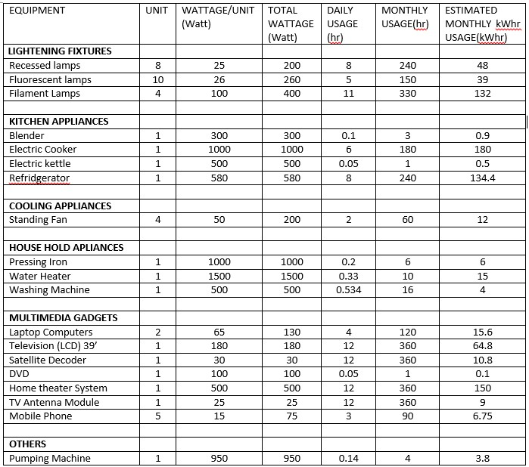^{Table 3.1:} Energy audit of the residential building
3.4 LOAD CLASSIFICATION
Loads can be divided into two main groups; controllable and uncontrollable loads. Controllable loads are loads that can be managed automatically. Uncontrollable loads are loads of which the use is completely determined by the end user. Nevertheless these uncontrollable loads can have some flexibility, but this flexibility depends exclusively on user operations.
3.4.1 CONTROLLABLE ELECTRIC LOADS
Controllable loads are non-essential electric loads that can be deferred for a brief period of time with little or no effect on comfort, convenience, or interruption of a process. There are several combinations of load control strategy that can be applied which are programmed for the least important loads to be shed first and restored last, and the highest priority loads to be shed last and restored first. They can be further classified into three types
      - TYPE I CONTROLLABLE LOADS
This type of controllable load includes various residential loads, such as fridges, washing machines, air conditioners, space cooling/heating, water heating, etc. These loads can be interrupted or shifted by the HEMs. The load curve can be reshaped by reducing demand. This type of load cannot inject power to the grid at any time.
      - TYPE II CONTROLLABLE LOADS
This type of controllable loads includes battery storage, Vehicle-to-Grid, the combined cooling heating, and power (CCHP), etc. Compared with the type I of controllable loads, this type of controllable loads can inject power to the grid. These loads can be charged from or discharged to the grid. In addition, this type of load has greater flexibility to be scheduled as controllable loads to accommodate grid needs.
      - TYPE III CONTROLLABLE LOADS
This type of controllable load includes the microgrid, Virtual power plants (VPP), etc. Although the microgrid and VPP have distributed generators, battery storage, renewable energy, etc., the loads take a great proportion in these systems. They are mainly loads and demand power from the grid in the connected-grid mode
    - UNCONTROLLABLE LOADS:
Uncontrollable loads are loads of which the use is completely determined by the end user. Nevertheless these uncontrollable loads can have some flexibility, but this flexibility depends exclusively on user operations. Switching off uncontrollable loads is normally not automated, home dwellers decide themselves whether they want to switch off certain uncontrollable loads or not. In the context of this work the uncontrollable loads are the core lightning and Multimedia system.
3.5 CLASSIFICATION OF THE USER LOADS
In order to take priority of the loads (preference) into consideration, the user loads are classified into uncontrollable and controllable loads as depicted in Table 3.2. The uncontrollable loads are the loads that fall into the category of L1. This category of loads demand instantaneous power and are therefore scheduled to run all through the daily cycle. The controllable loads in this paper are the loads that fall under the category of load L2 – L8. They operate at deferrable periods and do not demand instantaneous power. The controllable loads are spread over the 24 hours cycle of operation by allowing each of them to be operated only at the time they will be most needed in such a way that the peak load at any point in time is reduced. Each of the loads (L1-L8) is further divided into sub-load points as depicted in Table 1. For example, there are eight sub-load points (SL1₁–SL1₈) under the load category L1 and two sub-load points (SL2₁– SL2₂) under the load category L2. The daily preferred hour of use of the loads are depicted in Table 3. From the table, it can be observed that load L₁ is expected to be available for usage throughout the whole day depending on the battery state of charge. The state of charge of the battery is determined based on the available solar irradiation. The controllable loads (L2– L8) are distributed based on the hours of preference and can only come ON within those hours. However, their availability for usage depends on the state of charge of the battery.
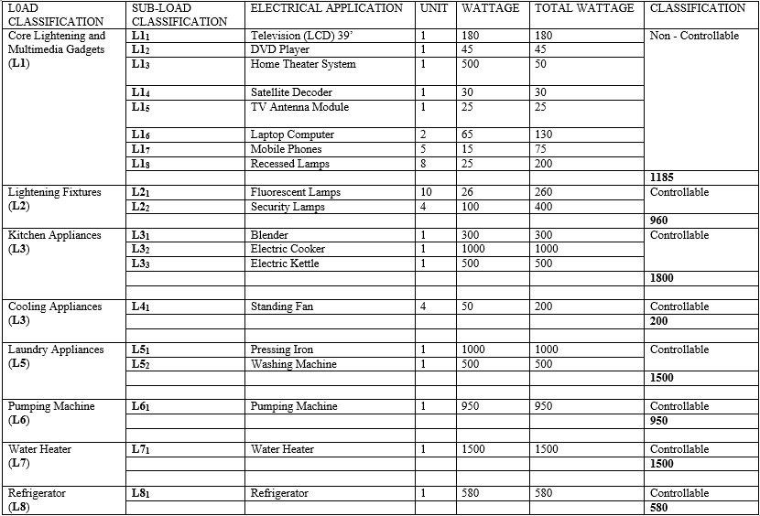
^{Table 3.2:} Classification of Household Appliances according to Home Activities Groups

  - PREFERENCE OF ENERGY SOURCES
The energy sources considered in this research are the PV system, battery storage and the Grid Supply. diagram of the hybrid system considered in this is as shown in figure 3.1 below.
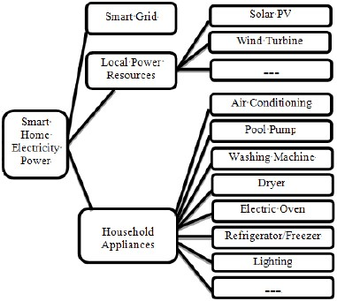
^{Figure 3.1} ^{Preference of Energy sources}
The renewable sources of energy are the primary sources considered in meeting the user’s load demand. In the event that the renewable energy is insufficient to meet the load demand, the battery bank is considered as the next level of energy source. The state of charge of the battery bank is consistently assessed and monitored. If the state of charge of the battery is greater than the minimum state of charge, the battery bank is used to supply the deficit. However, if the state of charge of the battery is at the preset minimum, a rule based controller assesses the deficit and switches ON the appropriate minimal load till the preset critical state is reached when the system is shutdown in the absence of other energy sources. A typical hourly load profile of a user is obtained from a survey. This is as shown in table 3.1 From the load profile, the hourly energy demand profile is obtained by
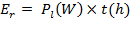

3.7 CLASSIFICATION OF LOAD BASED ON USER’S PRIORITY
An earlier study (Ayodele T.R and A.S.O Ogunjuyigbe., 2015) showed that certain load are more critical to the quality of life compared to the others. In this study, household energy utilization is partitioned into different energy sectors, and then the importance of each sector as it affects the basic quality of life of the intending users were determined. The result of the study showed that lighting is the most critical to quality of life followed by entertainment. Therefore, loads are classified based on the priority of the load as determined by its criticality to the quality of life. The classification is made such that L1 (core lightings and entertainments) is more preferred compared to L3 (kitchen Appliances) followed by L4 (Cooling Appliances) up to L8 (Refrigerator). Thus, the sub-load points SL1₁ – SL1₈ (Television (LCD) 39’, DVD Player, Home Theater System, Satellite Decoder, TV Antenna Module, Laptop Computer, Mobile Phones and Recessed Lamps) have a greater priority compared to SL2₁ – SL2₂ (Fluorescent Lamps and Security Lamps) up to SL8₁ (Refrigerator). This follows the user’s defined preference as shown in table 3.3 below.
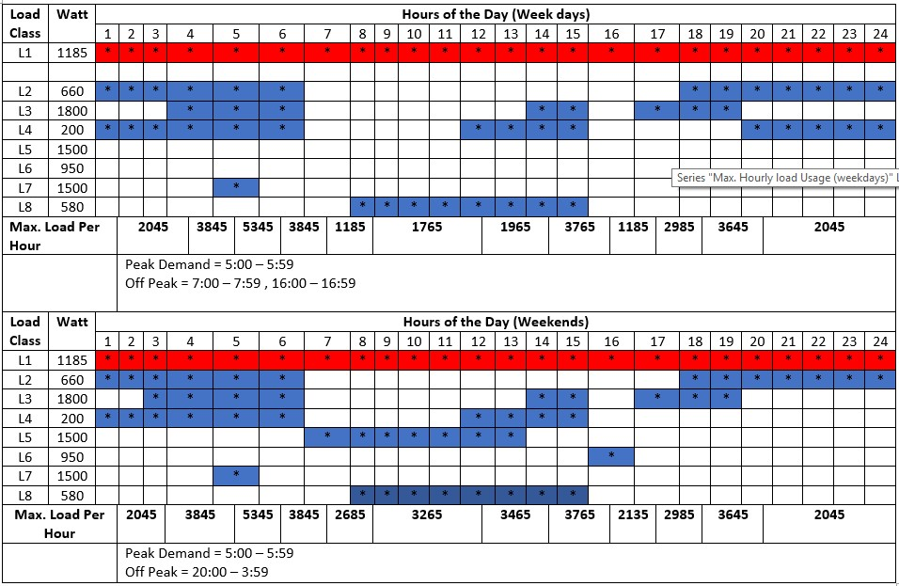^{Table 3.3:} Daily hour of use of controllable and uncontrollable loads
With respect to the above, the maximum obtainable load for each time slot was obtained as shown in the table 3.4 below. This signifies that there is a greater activity of house hold dwellers during the weekend compared to weekdays. This was exemplified by the high consumption during weekends. The peak and off peak periods for the weekday and weekends were obtained respectively as 05:00 – 05:59 and 07:00 – 07:59/16:00 – 16:59 for weekdays; 05:00 – 05:59 and 20:00 – 03:59 for weekends.
Also, the Peak and Off Peak loads were obtained as 5345Watts and 1185Watts for weekdays and 5345Watts and 2045Watts for weekends. This is as shown in the table below.
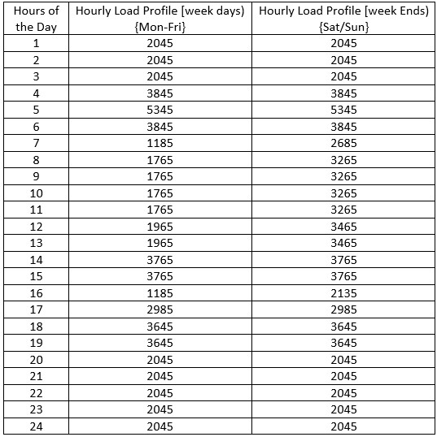
^{Table 3.4:} ^{maximum daily load profile}
From the above, the plot of the daily load profile was obtained which compares the maximum load profile of the 24 daily time slots for weekdays to that of weekends. This distinguishes each profile in relation to the other. As shown in the figure 3.2 below, the red signifies the load profile for week days, while the blue trend is the load profile for the weekend. The figure shows that there is a significant increase in the activities of the household dwellers as regards the use of appliances during the weekends
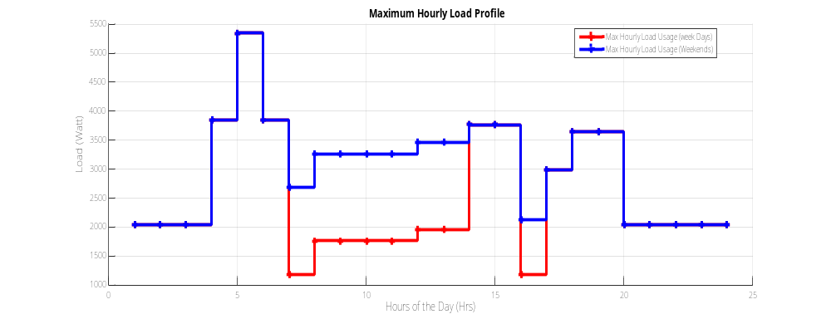
^{Figue 3.2:} Comparism Plot of hourly load profile during weekdays/weekends
3.8 ENERGY MANAGEMENT RULES
A rule-based system is a series of if-then statements that utilizes a set of assertions, to which rules are created on how to act upon those assertions. Rule-based systems often construct the basis of software artifacts which can provide answers to problems in place of human experts. Such systems are also referred as expert systems. Rule-based solutions are also widely applied in artificial intelligence-based systems making decisions without human interference.
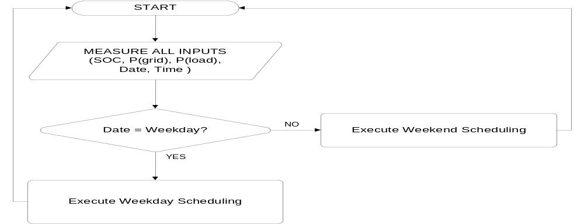
^{Figure 3.3:} ^{System Flowchart}
With respect to the aforementioned energy audit of the selected home, the classification of the user load, preference of energy source and classification of loads into controllable and uncontrollable load classes based on users priority; heuristic rules were written according to the table 3.5 and figure 3.4 & figure 3.5 which was afterwards used to implement the smart scheduling.
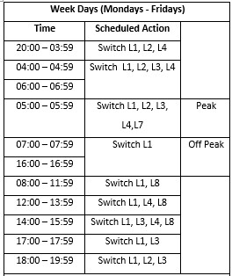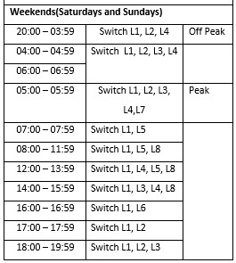
^{Table 3.5} Tabularized rules controlling the load schedule
3.8.1 RESOURCE SCHEDULING 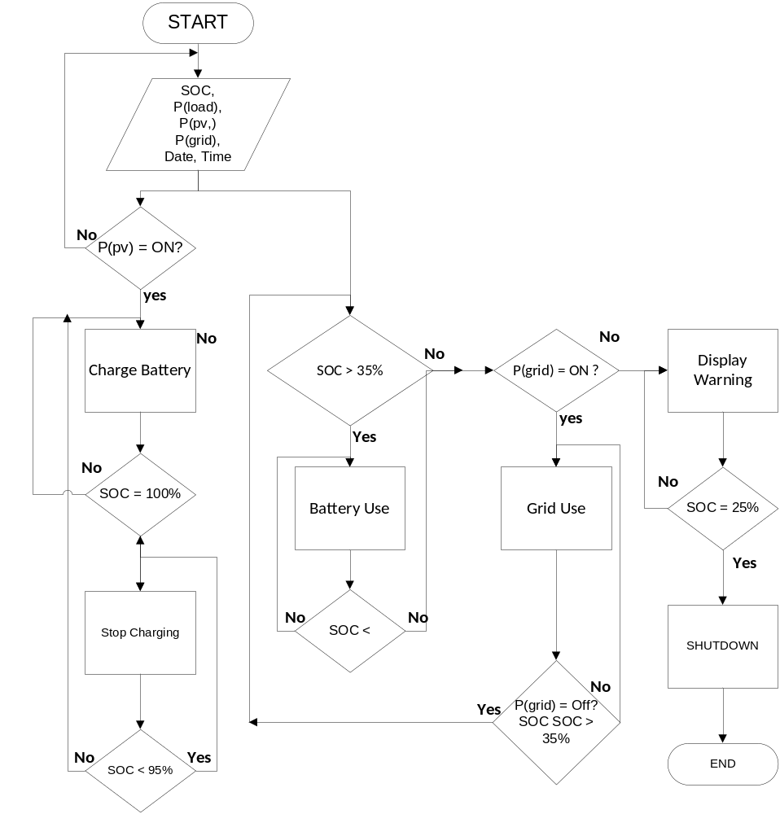
^{Figure 3.4:} ^{Resource scheduling rules}
According to the preference of the home users, the renewable energy was given priority over every other source of power. Hence, other energy resources can only be switched to when the renewable energy supply falls below the required demand. According to the rules, the battery is switched in use in as much as the state of charge (SOC) is greater than 35%. However, when the state of charge is less than the threshold, the HEMs queries the Grid source and switches to Grid supply till there is adequate renewable energy.
In situations of Grid resilience, while at the same time the State of charge (SOC) is less than the threshold, the rule triggers a warning and allows the Battery usage till the SOC is 25%. This allows the house hold dwellers to round up with whatever activities is being done before the system finally shuts down; to restart when the Grid or renewable energy source becomes available
3.8.1 LOAD SCHEDULING
With regards to table 3.3, the loads were allocated such that, at every predetermined point in time, the proportionate load is activated. The system takes a log of the date and time of activity and therefore switches the weekday’s schedules or weekend’s schedules as it applies to the event. This move to activate loads in their time frame is hinged on the state of the resource allocator as depicted in figure 3.5. Hence the energy resources scheduler influences the decision of the load scheduler i.e. in a situation where by the renewable energy is unavailable, the battery state of charge is less than the 35% threshold and the national Grid is not in supply, the load schedule is discontinued, and the system shuts down.
However, in some instances where the total load usage exceeds the maximum allowable load in a particular time slot, the rule triggers a warning and automatically sheds all load leaving the core lightning (L1₁) ON till the house hold users disengage excess load and restarts the HEMs system.
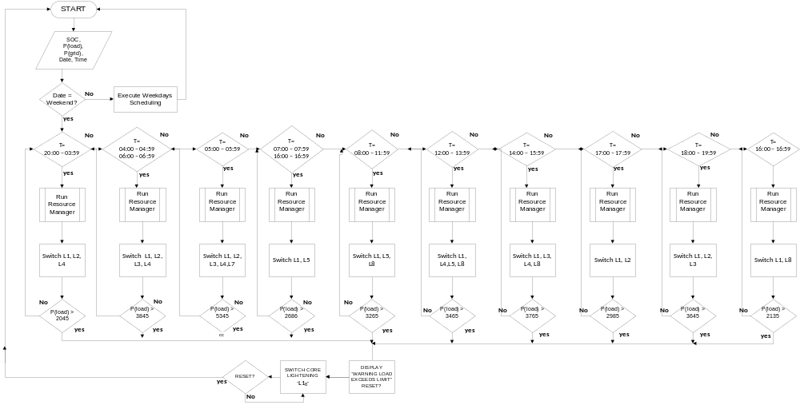 Figure 3.5: Load Scheduling rules (weekends)

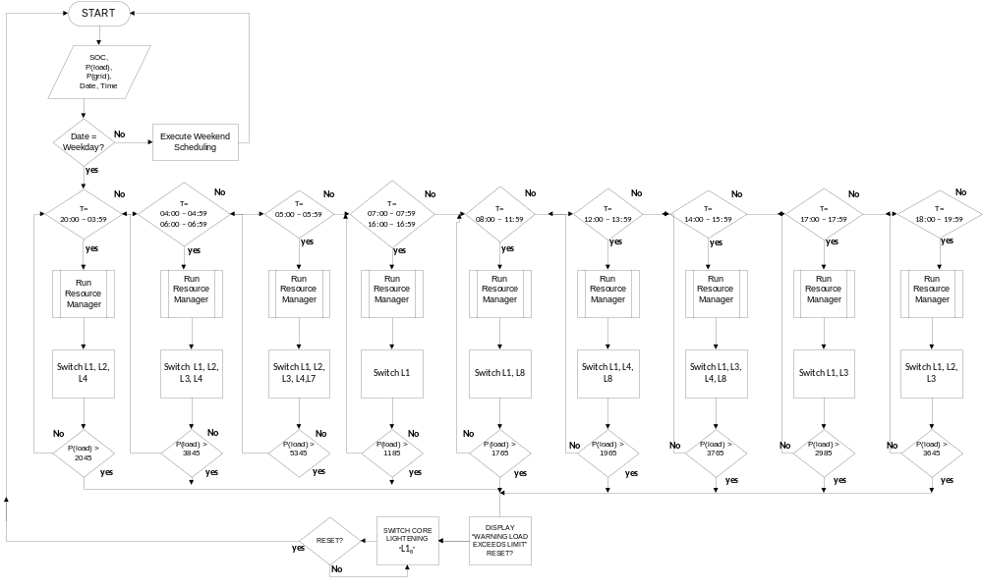 ^{Figure3.6:} Load Scheduling rules (weekdays)
3.9 IMPLEMENTATION
To show how a heuristic approach to solving the resource allocation and scheduling problem in the smart grid could be used with respect to the rules derived and the flowchart obtained, the Home Energy management was implemented using an Object oriented C++ algorithm, in a DEV C++ programming environment.
Several other approach has been presented, using Particle swarm optimization (PSO), genetic algorithm, neural fuzzy controller in the MATLAB/SIMULINK and JAVA. However, C++ is a language in which new and different features are built on top of an existing syntax. Because of this, it is referred to as a hybrid object-oriented programming language which reduces the complexity in expressing a program. Hence the move to implement the HEMs in the C++ environment.
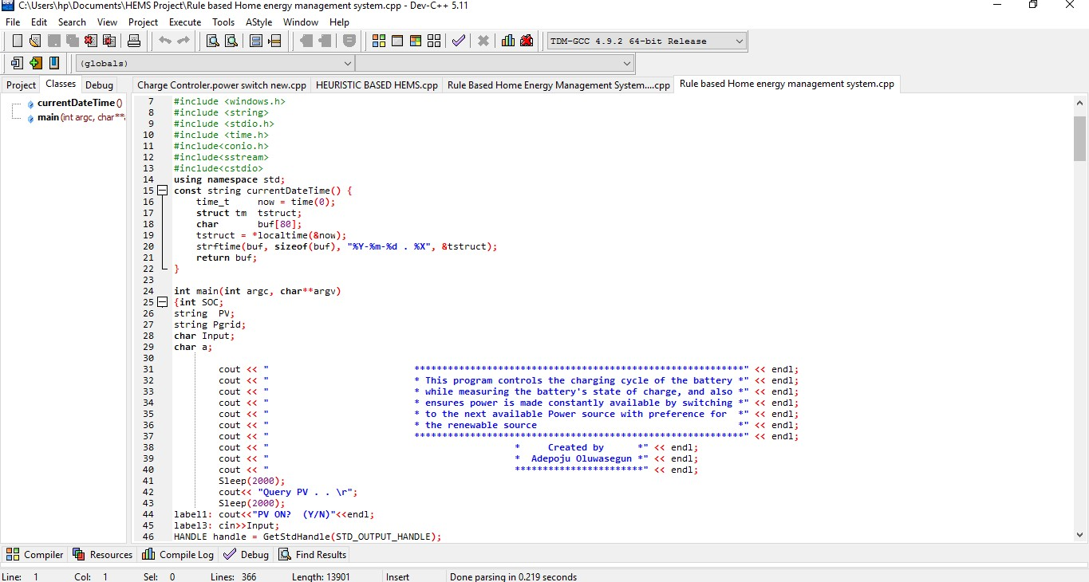^{Figure 3.7:} ^{DEV C++ Enviroment}
The implementation was achieved using eight standard libraries, which are #include <iostream> #include<windows.h> #include<string> #include<stdio.h> #include <time.h> #include<conio.h> #include<sstream> #include<cstdio> The selected C++ Standard Libraries provides a rich collection of functions for performing common mathematical calculations, string manipulations, character manipulations, input/output, error checking and many other useful operations. This makes the implementation easier, because these functions provide many of the capabilities need. The C++ Standard Library functions are provided as part of the C++ programming environment.
With respect to the rules derived, the time/date was initialized and functions written to distinguish weekdays and weekends. As shown below. These functions we called although the program progression
// Get current date/time, format is YYYY-MM-DD.HH:mm:ss
const string currentDateTime() {
time_t now = time(0);
struct tm tstruct;
char buf[80];
tstruct = *localtime(&now);
strftime(buf, sizeof(buf), "%Y-%m-%d . %X", &tstruct);
return buf;
}
int calcDaysSoFar( int year, int month );
bool isLeapYear( int year);
void printCalendar(int month /*1 = January*/, int year, int firstDay /* 0 = Sunday*/);
void printGridTop(int innerWidth);
void repeatChar(char ch, int numChar);
void drawDivider(int innerWidth);
void printGridBottom(int innerWidth);
const int firstYear = 1800;
const int dayOffset = 3;
const int firstLeapYear = 1804;

string dayNames[] = {"Sunday", "Monday", "Tuesday", "Wednesday", "Thursday", "Friday", "Saturday"};
string months[] = { "January", "February", "March", "April", "May", "June", "July", "August",
"September", "October", "November", "December"};
int daysInMonth[] = { 31,28,31,30,31,30,31,31,30,31,30,31} ; //standard year
After which the series of while loop, if/else, do while loop and switch statement was written to completely define the scheduling process.

4.0 CHAPTER 4
  - TEST AND OBSERVATIONS
The Object oriented C++ algorithm was successfully used to implement the rules, thereafter Unit and integration testing on the rule based HEMS program was conducted to ensure compliance with the predefined rules. The figures below are selected projections of the program during the test procedure in a windows 7 console environment.
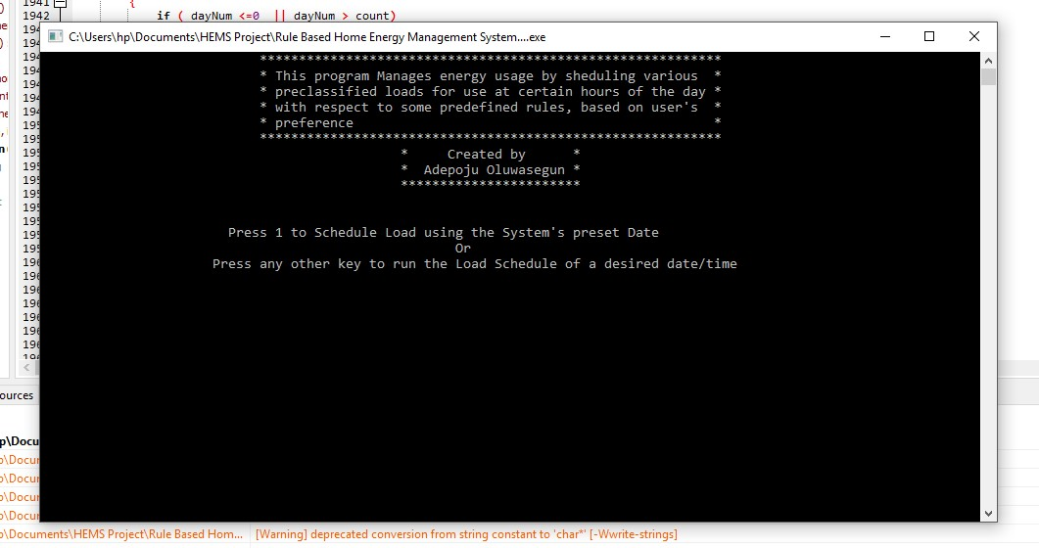
^{Figure 4.1a:} Program test Console Environment in windows 10.
As depicted above the implemented system gives room for the house hold dwellers to experience the load schedule of a desired day irrespective of the day’s schedule. This takes into consideration a practical scenario where there exists changes in the normal daily routine of household occupants. i.e., in periods of holidays when home user stays at home all through the day. Hence, household users can implement a weekend protocol on when such holidays falls on a weekday by simply running the load schedule of a weekend.
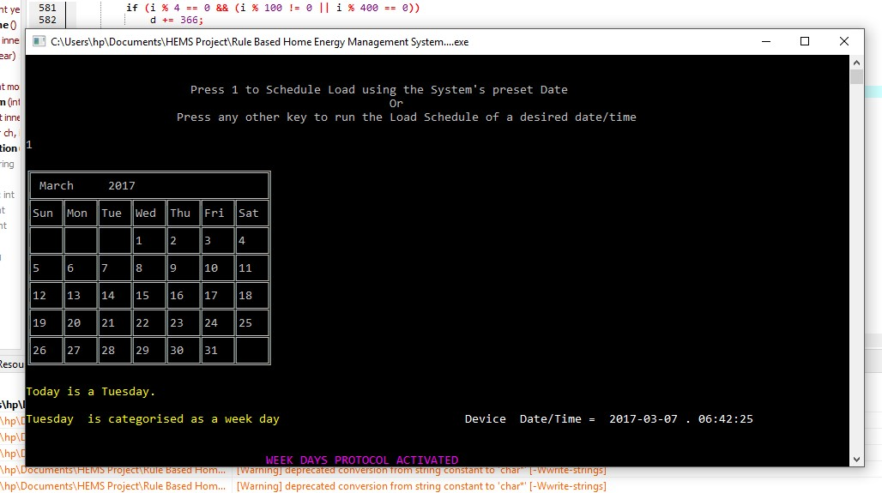
^{Figure 4.1b:} Program test Console Environment in windows 10.
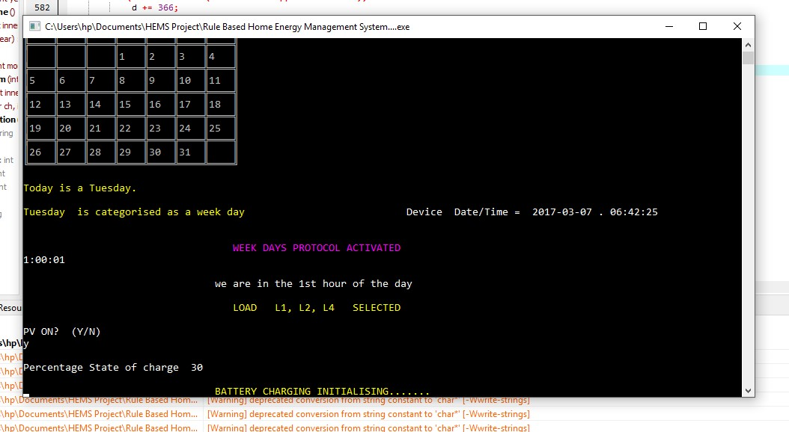
^{Figure 4.1c:} Program test Console Environment in windows 10.

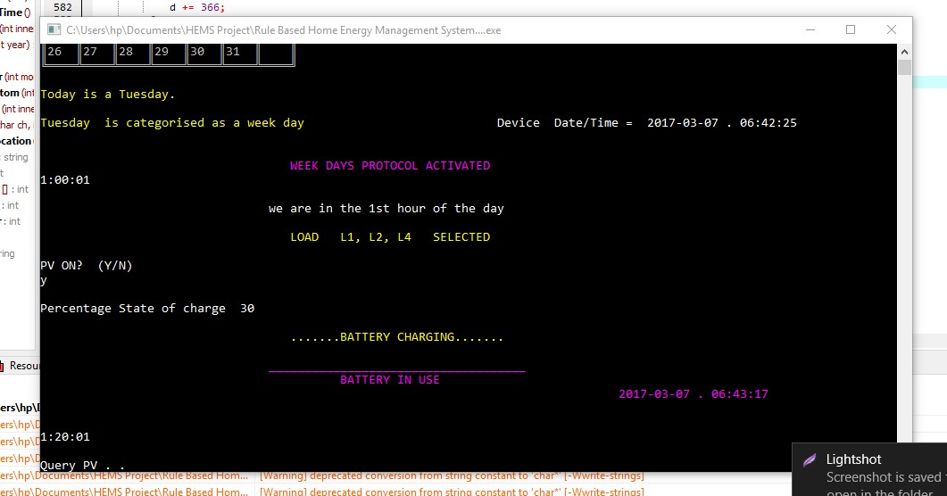
^{Figure 4.1d} Program test Console Environment in windows 10.
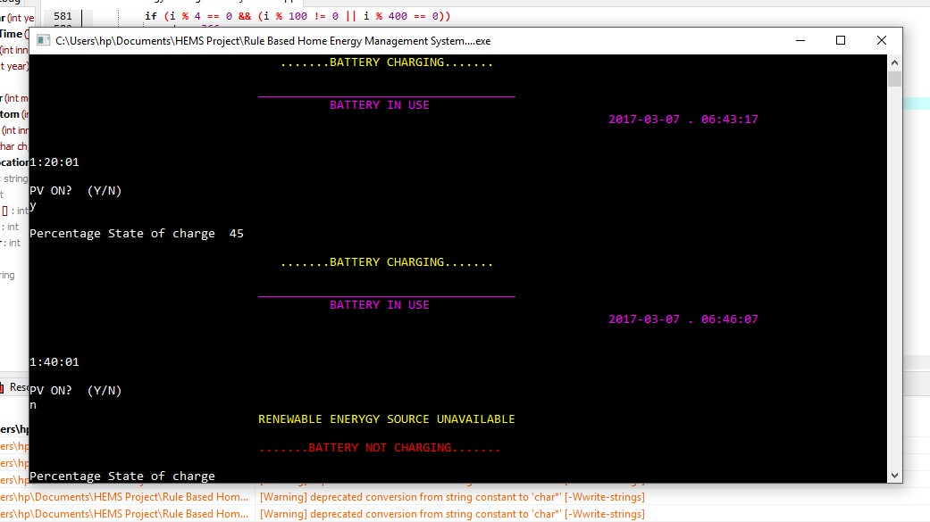
^{Figure 4.1e:} Program test Console Environment in windows 10.
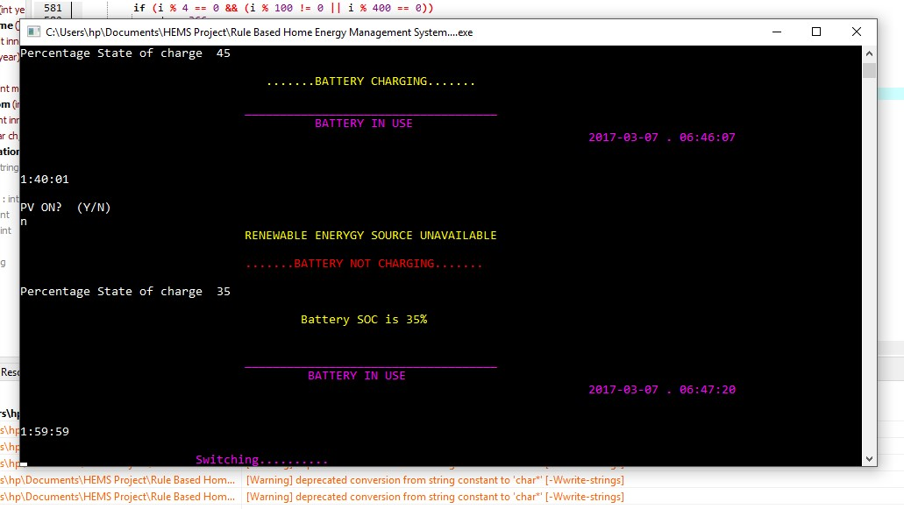
^{Figure 4.1f:} Program test Console Environment in windows 10.
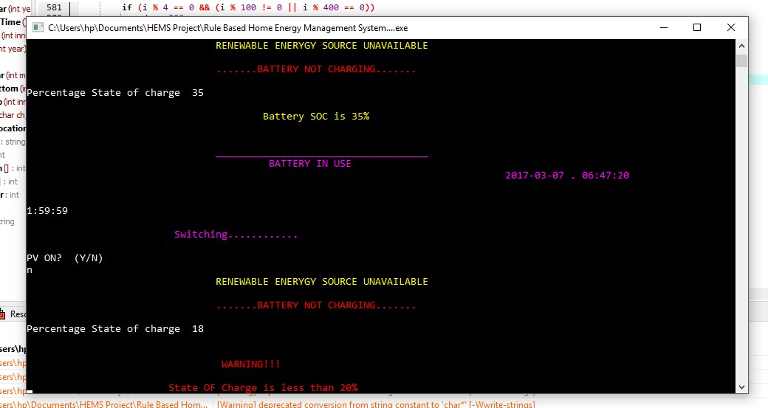
^{Figure 4.1g:} Program test Console Environment in windows 10.
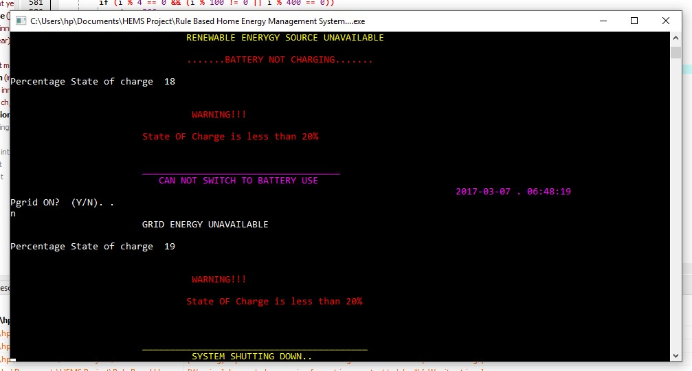
^{Figure 4.1h:} Program test Console Environment in windows 10.
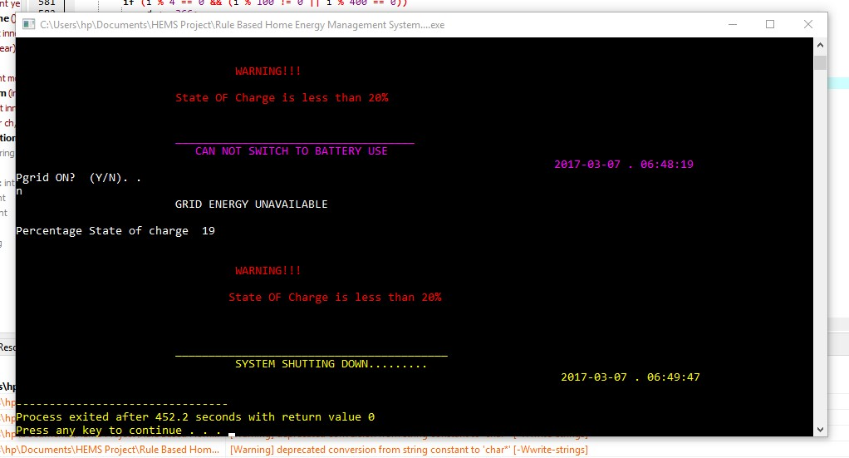
^{Figure 4.1i:} Program test Console Environment in windows 10.
Figures 4.1a – 4.1i above illustrates how the written rule were being asserted per time in accordance with the preference of the household dwellers. Hence, this schedule gives room for a controlled energy usage which rations power mismanagement and eventually power wastage or Overloading of the system. While higher priority is given to the renewable energy use, this contributes to a reduction the global warming and in the long run saves cost.
Below is a tabular illustration of the results obtained during simulation tests which illustrates the behavior of the system in practical senerios.
State of Grid | State of PV | State of Charge | System’s Decision
ON | ON | < 35% | Renewable energy selected for use  (battery charges)
ON | ON | >35% <100% | Renewable energy selected for use  (battery charges)
ON | ON | 100% | Renewable energy selected for use  (battery charging discontinued)
OFF | ON | <35% | Renewable energy selected for use  (battery charges)
OFF | ON | >35% <100% | Renewable energy selected for use  (battery charges)
OFF | ON | 100% | Renewable energy selected for use  (battery charging discontinued)
ON | OFF | <35% | Grid energy selected for use  (battery charging discontinued)
ON | OFF | >35% <100% | Renewable energy selected for use  (battery charging discontinued)
ON | OFF | 100% | Renewable energy selected for use  (battery charging discontinued)
OFF | OFF | <35% | System switches core lightening “L1₁” till SOC reaches 25% and shuts down
OFF | OFF | >35% <100% | Renewable energy selected for use  (battery charging discontinued)
OFF | OFF | 100% | Renewable energy selected for use  (battery charging discontinued)
Table 4.1: Test responses of the implemented system (resource manager)

Week Days (Mondays - Fridays)
Time | System’s Decision
20:00 – 03:59 | Load L1, L2, L4 Selected
04:00 – 04:59 | Load L1, L2, L3, L4 Selected
06:00 – 06:59 | Load L1, L2, L3, L4 Selected
05:00 – 05:59 | Load L1, L2, L3, L4,L7 Selected
07:00 – 07:59 | Load L1 Selected
16:00 – 16:59 | Load L1 Selected
08:00 – 11:59 | Load L1, L8 Selected
12:00 – 13:59 | Load L1, L4, L8 Selected
14:00 – 15:59 | Load L1, L3, L4, L8 Selected
17:00 – 17:59 | Load L1, L3 Selected
18:00 – 19:59 | Load L1, L2, L3 Selected
Weekends(Saturdays and Sundays)
20:00 – 03:59 | Load L1, L2, L4 Selected
04:00 – 04:59 | Load L1, L2, L3, L4 Selected
06:00 – 06:59 | Load L1, L2, L3, L4 Selected
05:00 – 05:59 | Load L1, L2, L3, L4,L7 Selected
07:00 – 07:59 | Load L1, L5 Selected
08:00 – 11:59 | Load L1, L5, L8 Selected
12:00 – 13:59 | Load L1, L4, L5, L8 Selected
14:00 – 15:59 | Load L1, L3, L4, L8 Selected
16:00 – 16:59 | Load L1, L6 Selected
17:00 – 17:59 | Load L1, L2 Selected
18:00 – 19:59 | Load L1, L2, L3 Selected
Table 4.1: Test responses of the implemented system (load manager)
As illustrated in table4.1a and 4.1b above, the system makes decision in line with the specified rules, does automatic shifting of energy consumption from grid draw to renewable power in case of power outage (grid resilience) and load management by scheduling of loads as specified.
Furthermore, the system’s decision in table 4.1 above was hinged on the outcome of the resource manager. I.e., during grid resilience at night times, the battery is switched and the load schedule continues. However, when the battery’s state of charge reaches a critical state the load schedule is discontinued and the emergency load activated which is the core lightening “L1₁” according to the guiding rules.

CHAPTER FIVE
5.1 CONCLUSION
The proposed approach provides a practical solution which take account of the local renewable energy generation, smart electronic appliances, decisions/commands of home owners, and environmental factors. It allows an improved energy saving (efficiency) and cost reduction in homes by appropriately managing each single appliance and energy sources depending on the pre-specified rules.
5.2 RECOMMENDATION
In this work, the activities scheduling is optimized over a single day, from midnight to midnight hence, users can not specify execution windows that end at late night outside the predefined pattern for weekdays and weekends. It would be interesting to overcome this limitation, either by implementing patterns of schedulable load usage and optimizing over a longer period. Also, implementations could be made to enable sale of excess energy resulting from Renewable energy generation to the national grid.

5.2 REFERENCES
A. Brissette,A.Hoke, D. Maksimović, and A. Pratt, “Amicrogrid modeling and simulation platform for system evaluation on a range of time scales,” in Proc. IEEE Energy Convers. Congr. Expo., Sep. 2011.
A. D. Giorgio and L. Pimpinella, “An event driven Smart Home Controller enabling consumer economic saving and automated Demand Side Management,” Applied Energy, vol. 96, pp. 92-103, 2012.
A. Marchiori, Q. Han, “Using Circuit-Level Power Measurements in Household Energy Management Systems” Proceedings ACM BuildSys 2009, Berkeley, USA, 2009.
A. Mohsenian-Rad and A. Leon-Garcia, “Optmal residential load control with price prediction in real-time electricity pricing environments,” IEEE Trans. Smart Grid, vol. 1, pp. 120–133, Sep. 2010.
A. Ruzzelli, A. Schoofs, G. O'Hare, “Real-Time Appliance Recognition And Profiling Through A Single Energy Monitoring Sensor, Proc. IEEE Conference on Sensor, Mesh and Ad Hoc Communications and Networks (SECON 2010), Boston, USA, 2010.
Ayodele, T.R. and A.S.O. Ogunjuyigbe, Increasing Household Solar Energy Penetration through Load Partitioning based on Quality of Life: The case Study of Nigeria. Sustainable Cities and Society 2015. 18: p. 21-31.
B. Ramachandran, S. K. Srivastava, C. S. Edrington, and D. A. Cartes, “An intelligent auction scheme for smart grid market using a hybrid immune algorithm,” IEEE Trans. Ind. Electron., vol. 58, no. 10, pp. 4603–4612, Oct. 2011.
C. Leong, A.R. Ramli, and T. Perumal, "A rule-based framework for heterogeneous subsystems management in smart home environment," IEEE Transactions on Consumer Electronics, vol. 55, no. 3, pp. 1208 –1213, 2009.
Chen C, Kishore S, Snyder LV, “ An innovative RTP-based residential power scheduling scheme for smart grid” 2011 IEEE .
D. Bonino, F. Corno, and F. Razzak, "Enabling machine understandable exchange of energy consumption information in intelligent domotic environments," Energy and Buildings, vol. 43, no. 6, pp. 1392-1402, 2011.
D. Cook and S. Das, Smart environments: technology, protocols and applications vol. 43: John Wiley & Sons, 2004.
D. J. Cook, M. Youngblood, III Heierman, E. O., K. Gopalratnam, S. Rao, A. Litvin, and F. Khawaja. Mavhome, "An agent-based smart home," in Proc. IEEE International Conference on Pervasive Computing and Communications, 2003, pp. 521–524,.
D. L. Ha, S. Ploix, E. Zamai, and M. Jacomino, “Tabu search for the optimization of household energy consumption,” in Proc. 2006 IEEE Int. Conf. Inf. Reuse Integr., pp. 86–92.
D. M. Han and J. H. Lim, "Design and implementation of smart home energy management systems based on zigbee," IEEE Transactions on Consumer Electronics, vol. 56, no. 3, pp. 1417- 1425, 2010.
D. Markovic, D. Cvetkovic, D. Zivkovic, and R. Popovic, "Challenges of information and communication technology in energy efficient smart homes," Renewable and Sustainable Energy Reviews, vol. 16, pp. 1210–1216, 2012.
Du P, Lu N, “Appliance Commitment for household load scheduling” IEEE Transaction on Smart Grid 2011, 2: 411-419
Energy Information Administration, “International Energy Outlook 2010 - Highlights”, http://www.eia.doe.gov/oiaf/ieo/highlights.html.
F. K. Aldrich, "Smart homes: past, present and future," in Inside the smart home, ed: Springer, 2003, pp. 17-39.
F. Karmali, M. Polak, and A. Kostov, "Environmental control by a brain-computer interface," in Engineering in Medicine and Biology Society, 2000. Proceedings of the 22nd Annual International Conference of the IEEE, 2000, pp. 2990-2992.
F. Schweppe, B.Daryanian, and R. Tabors, “Algorithms for a spot price responding residential load controller,” IEEE Trans. Power Syst., vol. 4, pp. 507–516, May 1989.
Gligor A, Grif H, Oltean “ Considerations on an intelligent buildings management system for an optimized energy consumption” 2006 IEEE International Conference on Automation, Quality and testing, Robotics; 2006, 1:280-284 (mathematical model of house hold management)
H. Farhangi, "The path of the smart grid," Power and Energy Magazine, IEEE, vol. 8, no. 1, pp. 18-28, January-February 2010.
H. Lund and E. Mnster, "Management of surplus electricity-production from a fluctuating renewable-energy source," Applied Energy, vol. 76, no. 13, pp. 65–74, 2003.
Ha DL, Ploix S, Zamai E, Jacomino M Tabu “ Search for the optimization of house hold energy consumption”, 2006 IEEE International Conference in Information Reuse and Integration;2006, 86-92.
I. Koutsopoulos and L. Tassiulas, “Challenges in demand load control for the smart grid,” IEEE Network, vol. 25, no. 5, pp. 16–21, Sep.–Oct. 2011.
J. M. Carrasco, L. G. Franquelo, J. T. Bialasiewicz, E. Galvan, R. C. P. Guisado, Ma A. M. Prats, J. I. Leon, and N. Moreno-Alfonso, “Power-electronic systems for the grid integration of renewable energy Sources: A survey,” IEEE Transactions on Industrial Electronics, vol. 53, no. 4, pp. 1002–1016, 2006.
J. Stragier, L. Hauttekeete, and L. D. Marez, "Introducing smart grids in residential contexts: Consumers’ perception of smart household appliances,", 2010, pp. 135–142
K. Aduda, W. Zeiler, and G. Boxem, "Smart Grid-BEMS: The Art of Optimizing the Connection between Comfort Demand and Energy Supply," in Intelligent Systems Design and Engineering Applications, 2013 Fourth International Conference on, 2013, pp. 565-569.
K. Kok, S. Karnouskos, D. Nestle, A. Dimeas, A. Weidlich, C. Warmer, et al., "Smart houses for a smart grid," in Electricity Distribution-Part 1, 2009. CIRED 2009. 20th International Conference and Exhibition on, 2009, pp. 1-4.
M. A. A. Pedrasa, T. D. Spooner, and I. F. MacGill, "Coordinated scheduling of residential distributed energy resources to optimize smart home energy services," Smart Grid, IEEE Transactions on, vol. 1, pp. 134-143, 2010.
M. Chetty, D Tran, R. E. Grinter, “Getting to Green: Understanding Resource Consumption in the Home”, Proc. UbiComp 2008, New York, USA 2008.
M. Erol-Kantarci and H. T. Mouftah, "Wireless Sensor Networks for Cost-Efficient Residential Energy Management in the Smart Grid," Smart Grid, IEEE Transactions on, vol. 2, pp. 314-325, 2011.
M. J. Kofler, C. Reinisch, and W. Kastner, "A semantic representation of energy-related Information in future smart homes," Energy and Buildings, vol. 47, pp. 169–179, 2012.
M. Jahn, M. Jentsch, C.R. Prause, F. Pramudianto, A. Al-Akkad, and R. Reiners, "The energy aware smart home," in Proc. International Conference on Future Information Technology, 2010, pp. 1-8.
M. Kuzlu, M. Pipattanasomporn, and S. Rahman, "Hardware demonstration of a home energy management system for demand response applications," Smart Grid, IEEE Transactions on, vol. 3, pp. 1704-1711, 2012.
M. Roscia, M. Longo, and G. C. Lazaroiu, "Smart City by multi-agent systems," in Renewable Energy Research and Applications (ICRERA), 2013 International Conference on, 2013, pp. 371-376.
P. C. Loh, L. Zhang, and F. Gao, "Compact integrated energy systems for distributed generation," IEEE Transactions on Industrial Electronics, vol. 60, no. 4, pp. 1492-1502, 2013.
P. Fox-Penner, Smart power: climate change, the smart grid, and the future of electric utilities: Island Press, 2010.
P. Joonseok, M. Mikyeong, H. Seongjin, and Y. Keunhyuk, "Development of simulation system for validating contextual rule in smart home," in Proc. International Conference on Advanced Communication Technology, 2007, vol. 2, pp. 1143–1146.
P. Pellegrino, D. Bonino, and F. Corno, "Domotic house gateway," in Proc. the 2006 ACM symposium on Applied computing, 2006, pp. 1915-1920.
R. Harper, "Inside the smart home: Ideas, possibilities and methods," in Inside the smart home, ed: Springer, 2003, pp. 1-13.
R. J. Cole and Z. Brown, "Reconciling human and automated intelligence in the provision of occupant comfort," Intelligent Buildings International, vol. 1, no. 1, pp. 39–55, 2009.
R. S. Cowan, "The" industrial revolution" in the home: Household technology and social change in the 20th century," Technology and Culture, pp. 1-23, 1976.
S. D. Ramchurn, P. Vytelingum, A. Rogers, and N. Jennings, "Agent-based control for decentralised demand side management in the smart grid," in The 10th International Conference on Autonomous Agents and Multiagent Systems-Volume 1, 2011, pp. 5-12.
S. Darby, “The Effectiveness of Feedback on Energy Consumption”, Techinical Report, Environmental Change Institute, University of Oxford, 2006.
S. Massoud Amin and B. F. Wollenberg, “Toward a smart grid: power delivery for the 21st century,” Power and Energy Magazine, IEEE, vol. 3, no. 5, pp. 34–41, 2005.
Sheetal Shinkhede ”Power Scheduling Approach in Smart Home” International Journal of Engineering Research and Development (IJERD) ISSN: 2278-067X Recent trends in Electrical and Electronics & Communication Engineering (RTEECE 17th – 18th April 2015)
T. Catania, “Appliances & the smart grid,” ASHRAE JOURNAL, vol. 54, no. 2, pp. 72-74, 2012.
T. M. Chen, "Smart grids, smart cities need better networks [Editor's Note]," Network, IEEE, vol. 24, pp. 2-3, 2010.
T. Yamazaki, "Beyond the smart home," in Hybrid Information Technology, 2006. ICHIT'06. International Conference on, 2006, pp. 350-355. 146
Tajikawa T,Yoshino H, Tabaru T, Shin S “The energy conservation by information appliance”, Proceedings of the 41st SICE Annual Conference, 2002,5:3127-3130.(Genetic algorithm)
US DOE Energy Information Administration, “Commercial Buildings Energy Consumption Survey”, 2003. www.eia.doe.gov/emeu/cbecs.
V. Ricquebourg, D. Menga, D. Durand, B. Marhic, L. Delahoche, and C. Loge, "The smart home concept: our immediate future," in E-Learning in Industrial Electronics, 2006 1ST IEEE International Conference on, 2006, pp. 23-28.
Visit Hirankitti “An Agent Framework for Home Energy Management System” Proceedings of the World Congress on Engineering 2015 Vol I WCE 2015, July 1 - 3, 2015, London,U.K.
W. Wang, Y. Xu, and M. Khanna, "A survey on the communication architectures in smart grid," Computer Networks, vol. 55, pp. 3604-3629, 2011.
W.-l. ZHANG, Z.-z. LIU, M.-j. WANG, and X.-s. YANG, "Research Status and Development Trend of Smart Grid [J]," Power System Technology, vol. 13, p. 004, 2009.
X. Feng, "Home Networking," Dec1999, vol. 16, 1999.
X. Jiang, M. Van Ly, J. Taneja, P. Dutta, D. Culler, “Experiences with A High-Fidelity Wireless Building Energy Auditing Network”, Proc. ACM SenSys 2009, Berkeley, USA, 2009
Y. Agarwal, T. Weng, R. Gupta. “The Energy Dashboard: Improving the Visibility of eEnergy Consumption at a Campus-wide Scale”, Proc. ACM BuildSys 2009, Berkeley, USA, 2009.
Y. Fu, N. Kottenstette, Y. Chen, C. Lu, X. D. Koutsoukos, and H. Wang, “Feedback thermal control for real-time systems,” in Proc. 16th IEEE Real-Time Embedded Technol. Appl. Symp., Apr. 2010, pp. 111–120.
Z. Yu, L. Jia, and L. Tong “Modelling and Stochastic Control for Home Energy Management” IEEE TRANSACTIONS ON SMART GRID, VOL. 4, NO. 4, DECEMBER 2013
Zhao, W., Ding, L., Cooper, P. & Perez, P. (2014). Smart Home Electricity Management in the Context of Local Power Resources and Smart Grid. Journal of Clean Energy Technologies, 2 (1), 73-79.

